**Making a Mark – 2020**

Making a Mark is an art exhibition featuring drawings, paintings and mixed media pieces by the students of professional artist and tutor Mark Lippett.

Classes are normally held in the community at Haughton, Penkridge and Burntwood and are aimed at people of all abilities and backgrounds.   
  
Since late March, due to the global pandemic, students have been learning online with Mark via email, Social Media and video calls. The determination and commitment of the students has meant that they have continued to develop creatively despite the lockdown.

The exhibition was originally scheduled for May at a venue in Stafford but is now taking the form of an Online Show.

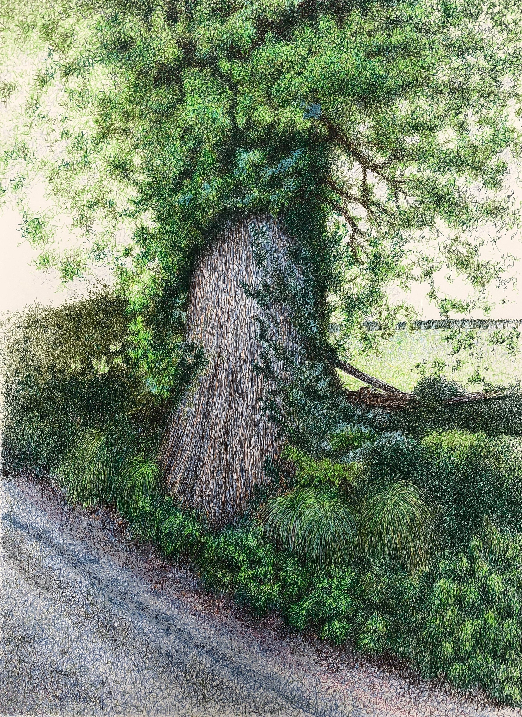

Image by Mary Wilebur